# OpenEuler RISC-V Xfce安装测试

## 1、编译支持视频输出的 qemu

mkdir openEuler/Xfce  
cd ~/openEuler/Xfce  
git clone https://gitlab.com/wangjunqiang/qemu  
cd qemu  
git switch display  
sudo apt install libgtk-3-dev  
sudo apt install libepoxy-dev  
sudo apt install build-essential autoconf automake autotools-dev pkg-config bc curl gawk git bison flex texinfo gperf libtool patchutils mingw-w64 libmpc-dev libmpfr-dev libgmp-dev libexpat-dev libfdt-dev zlib1g-dev libglib2.0-dev libpixman-1-dev libncurses5-dev libncursesw5-dev meson libvirglrenderer-dev libsdl2-dev -y  
./configure --target-list=riscv64-softmmu --prefix=/home/XXX/openEuler/Xfce/program/riscv64-qemu --enable-kvm --enable-sdl --enable-gtk --enable-virglrenderer --enable-opengl

"XXX"根据自己主机用户名设置

make -j8  
make install  
vim ~/.bashrc

按“Ins”键，在文件末尾复制以下内容：

export QEMU_HOME=/home/XXX/openEuler/Xfce/program/riscv64-qemu  
export PATH=$QEMU_HOME/bin:$PATH

"XXX"根据自己主机用户名设置

按下“Esc”键，而后输入“:wq”,而后回车键

source ~/.bashrc  
echo $PATH

此时应该输出

/home/XXX/openEuler/Xfce/program/riscv64-qemu/bin:/usr/local/sbin:/usr/local/bin:/usr/sbin:/usr/bin:/sbin:/bin:/usr/games:/usr/local/games:/snap/bin



查看qemu安装情况

qemu-system-riscv64

此时应有以下输出为安装成功



## 2、下载openEuler镜像并安装

cd ../  
wget https://mirror.iscas.ac.cn/openeuler-sig-riscv/openEuler-RISC-V/development/deprecated/2203/Image/openEuler-22.03.riscv64.qcow2  
git clone https://gitee.com/yunxiangluo/riscv-openeuler.git  
cp ./riscv-openeuler/chapter3/class1/Image .  
vim run.sh

按“Ins”键，复制以下内容：

![3](C:\Users\11833\Desktop\3.png)#!/bin/bash  
  
qemu-system-riscv64 \  
 -nographic -machine virt \  
 -smp 8 -m 4G \  
 -display sdl -vga std \  
 -kernel Image \  
 -append "loglevel=3 swiotlb=1 console=ttyS0 rw root=/dev/vda1" \  
 -drive file=openEuler-22.03.riscv64.qcow2,format=qcow2,id=hd0 \  
 -object rng-random,filename=/dev/urandom,id=rng0 \  
 -device virtio-rng-device,rng=rng0 \  
 -device virtio-blk-device,drive=hd0 \  
 -device virtio-net-device,netdev=usernet \  
 -netdev user,id=usernet,hostfwd=tcp::12055-:22 \  
 -device qemu-xhci -device usb-tablet -device usb-kbd

按下“Esc”键，而后输入“:wq”,而后回车键

chmod +x run.sh  
./run.sh

有qemu视频输出框（图左黑框）为安装成功

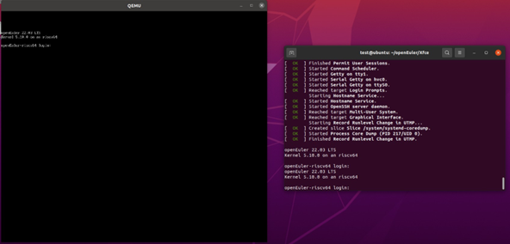

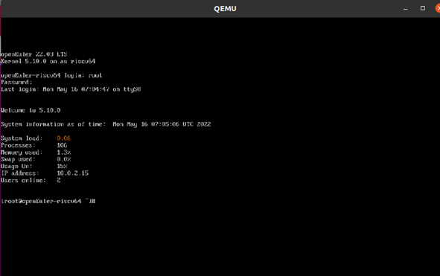

## 3、更新openEuler源

在ubuntu20.04宿主机上

ssh root@127.0.0.1 -p 12055

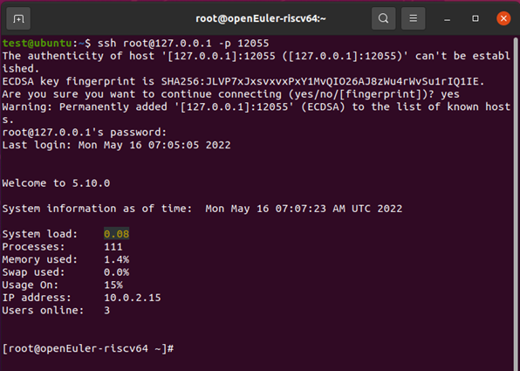

vim /etc/yum.repos.d/openEuler.repo

按“Ins”键，删除原有内容，复制以下内容：

[22.03]
  
name=22.03
  
baseurl=http://obs-backend.tarsier-infra.com:82/openEuler:/22.03/openEuler_2203/
  
enabled=1
  
gpgcheck=0
  
  
[22.03Epol]
  
name=22.03Epol
  
baseurl=http://obs-backend.tarsier-infra.com:82/openEuler:/22.03:/Epol/openEuler_22.03_Epol/
  
enabled=1
  
gpgcheck=0

按下“Esc”键，而后输入“:wq”,而后回车键

## 4、安装Xfce4桌面

yum install libxfce4util xfconf libxfce4ui exo garcon thunar thunar-volman tumbler xfce4-appfinder xfce4-panel xfce4-power-manager xfce4-settings xfdesktop xfwm4 xfce4-session xfce4-terminal -y
  
yum install xorg-x11-xinit xorg-x11-server -y
  
dnf upgrade pango
  
yum update glib2

启动Xfce4桌面

startxfce4

在qemu视频输出窗口稍后会有如下反应为安装成功

